**British Airways Survey Dashboard Report**

**Prepared by:** Divyanshi Singh  
**Tool Used:** Tableau

**1. Introduction**

This report presents an analysis of British Airways customer reviews, visualized using a Tableau dashboard. The primary objective is to assess customer satisfaction levels across various service parameters and identify trends based on different factors such as time, country, and aircraft type.

**2. Dashboard Overview**

The dashboard consists of multiple interactive elements, including filters, time-based trends, geographical analysis, and categorical comparisons. Key components include:

**2.1 Key Performance Indicators (KPIs)**

At the top of the dashboard, six KPIs summarize the overall customer ratings for different service aspects:

* **Overall Rating:** 4.3
* **Cabin Staff Service:** 3.9
* **Entertainment:** 2.1
* **Food & Beverages:** 3.1
* **Ground Service:** 3.3
* **Seat Comfort:** 3.1
* **Value for Money:** 2.9

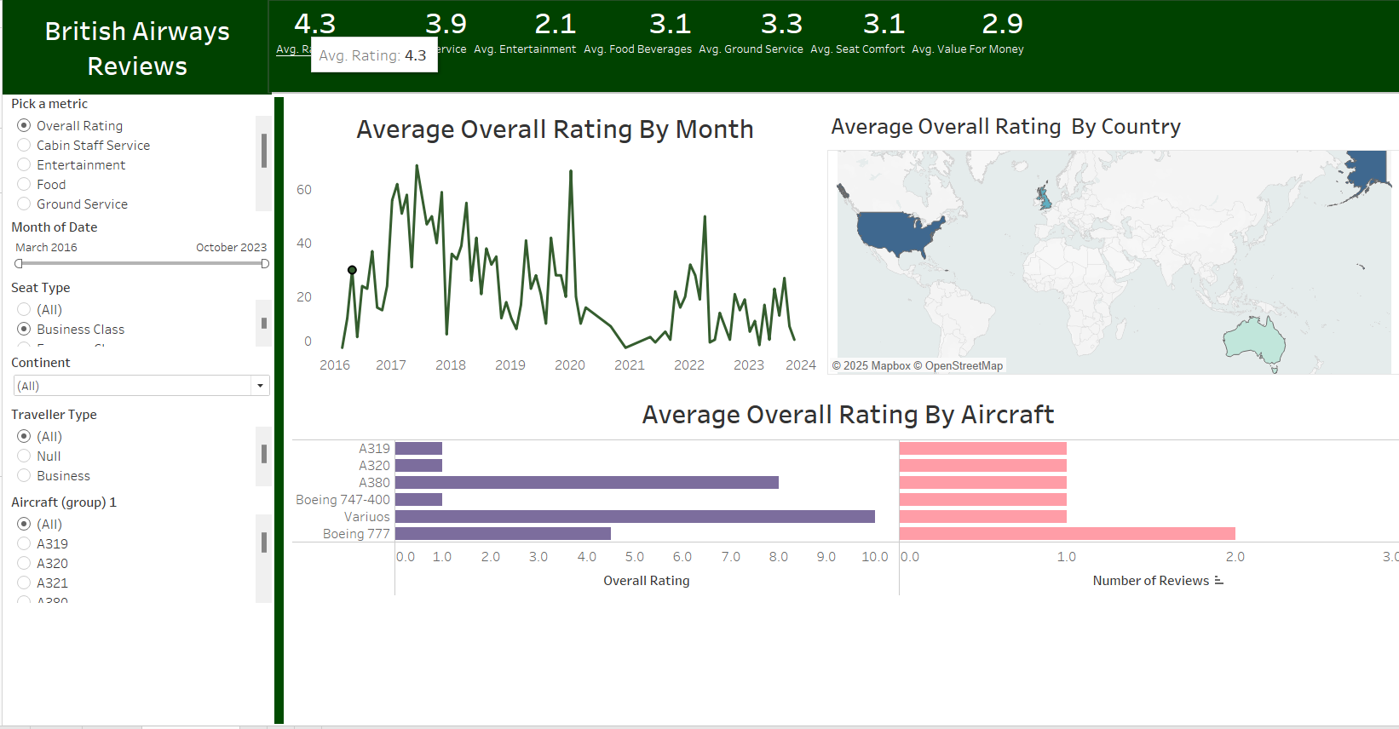

**3. Data Visualizations & Analysis**

**3.1 Average Overall Rating by Month**

* This line graph represents the fluctuations in customer ratings from March 2016 to October 2023.
* A significant drop is visible around 2020, likely due to the impact of the COVID-19 pandemic.
* Post-2021, the ratings show a gradual recovery but do not reach pre-pandemic levels.

**3.2 Average Overall Rating by Country**

* A world map highlights the geographical distribution of ratings.
* The United States, the United Kingdom, and Australia appear as major contributors to customer feedback.
* Potential variations in satisfaction levels across countries could be explored further.

**3.3 Average Overall Rating by Aircraft**

* A horizontal bar chart displays the customer ratings for different aircraft models.
* Aircraft such as **A380** and **Boeing 747-400** show higher ratings compared to others.
* **Boeing 777** and some other models have relatively lower ratings.

**4. Dashboard Interactivity**

Several filter options are provided on the left panel, allowing users to customize the analysis based on:

* **Service Parameter:** Overall rating, cabin staff service, entertainment, food, ground service.
* **Month of Date:** Selectable date range from March 2016 to October 2023.
* **Seat Type:** Business Class, Economy Class.
* **Continent:** Allows filtering by geographic region.
* **Traveller Type:** Business or leisure.
* **Aircraft Type:** Selection of different aircraft models.

These interactive controls enable a deep dive into customer reviews for better insights.

**5. Key Insights & Recommendations**

**5.1 Key Insights**

* Customer ratings declined sharply during the pandemic but have shown a slow recovery.
* Entertainment services and value for money have the lowest scores, indicating areas for improvement.
* Boeing 747-400 and A380 receive better customer reviews, suggesting passenger preference for these aircraft types.
* The United States and the UK contribute significantly to the reviews, highlighting key markets for British Airways.

**5.2 Recommendations**

* **Enhance In-Flight Entertainment:** Given the low rating, British Airways should consider updating its entertainment offerings.
* **Improve Food & Beverage Quality:** Customer satisfaction in this category is below average, requiring better meal options.
* **Analyze Regional Preferences:** Further research on country-wise variations in customer satisfaction can help tailor services accordingly.
* **Aircraft Performance Analysis:** Since some aircraft types have better ratings, BA should consider customer feedback when scheduling flights.

**6. Conclusion**

This Tableau dashboard effectively visualizes British Airways customer feedback trends over time, across regions, and by aircraft type. The analysis highlights key areas of strength and improvement. By leveraging these insights, British Airways can enhance its service quality and improve overall passenger satisfaction.

**7. Appendix**

* **Data Source:** British Airways customer reviews dataset, Kaggle.
* **Visualization Tool:** Tableau.
* **Date Range Covered:** March 2016 – October 2023.